# IT 230 Coding Activity Submission Template

# 

Document your work in the coding activity by completing each of the following items:

1. Provide a screenshot of the output that resulted from running your program successfully in Visual Studio. See the coding assignment instructions for an example of what should be included in the screenshot. Your screenshot must include the following elements:
   1. Your last name as the first printed text on the screen
   2. Verification that the program is fully functioning and data results are accurate for the given problem

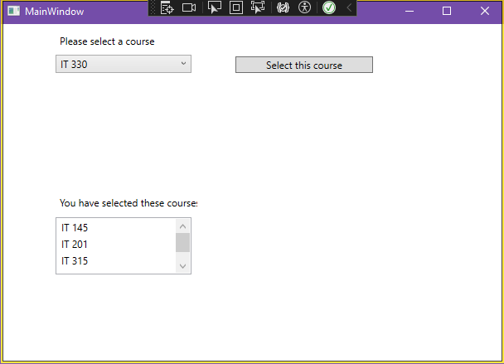

1. Copy and paste the source code text you wrote for this assignment from the *.cs file into the space below. Only providing the *.cs files or a screenshot does not meet the requirements for this part of the assignment. Code should be logically organized. It should also follow proper syntax and conventions noted in the Coding Activity Guidelines and Rubric.

namespace CreateClassesObjs

{

public class Course //create public class called Course

{

private string Coursename; //create private string field

//create public method to set the value of the private field

public void setName(string name)

{

this.Coursename = name; //set the value of the private field

}

public string getName()

{

return this.Coursename; //return the value of the private field

}

public override string ToString()

{

return this.Coursename; //control what is displayed in the combo box

}

}

}

1. Show that you understand the task by explaining the design of your program in the space below. Include the process and steps you took to write your code. Explain how you arrived at the solution to the problem and completed the activity.

To start this assignment, I first read the instructions all the way through and then looked at the other .cs files that I could see in the Solution Explorer (App and MainWindow). Since there were no errors in App I could close out of that one. I then checked out MainWindow and noticed that the errors were all around the .setName method. This all checks out since in the instructions it said that I would need to make sure that Course has a method to set the name field to a given string value. I then created a C# class file and made sure I had the namespace at the top so the code knew what to reference. I then created and named the public class Course. Next, I needed a string to hold the name of the course, so I created a private string named courseName and did not assign it any value so it could be a placeholder. I then needed to create my method to set the names of the course. I created a public method that had the string parameter name so that I could access the private string inside of the setter method and assign it the correct name. Then I needed to make the way to get the course name, so I created another public method that just returned that string value of the course selected. Lastly, I needed to add in the method that overrides the ToString() as I was instructed in the word doc. I copy and paste the given code in, and then since I was given the instructions that the method should return the name field, I just did the same return statement that I had previously in the getName() method.

1. Reflect on your learning experience and what you learned from completing the activity.

This assignment was a good learning experience for me in the sense of creating getter and setter methods in C#. I have created them in other languages before, and they do follow the same logic, so it was not too difficult, but regardless, it is still valuable to practice it in the current language I am learning. This was also a good learning opportunity when talking about adding in a class to an already existing project in Visual Studio 2022. This was something that gave me a bit of trouble just because at first it was not being created where I wanted it to be created, which was with the other .cs files in the Solution Explorer. However, I did end up figuring it out, and it proved to be very helpful, as I am sure this will not be the last time I need to do something like this. Those were the main takeaways I had for learning experience while doing this assignment.